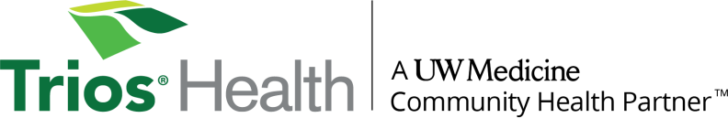
Family Medicine Residency 2026 Match Pledge

- We have 4 categorical positions for which we will interview a minimum of 105 candidates.
- Interviews will be offered starting on September 24th, 2025 to fill the 105 interview slots.
- We will NOT invite more candidates to interview than we have interview slots available.
- Once an interview is offered, we will wait 48 hours before offering that spot to another candidate.
- The application deadline is February 1, 2025. We will not review applications received after this date.
- All interviews will be virtual and take place between October 16th and January 26th.
- We will certify our rank list no later than February 14th, prior to any social events that we plan.

